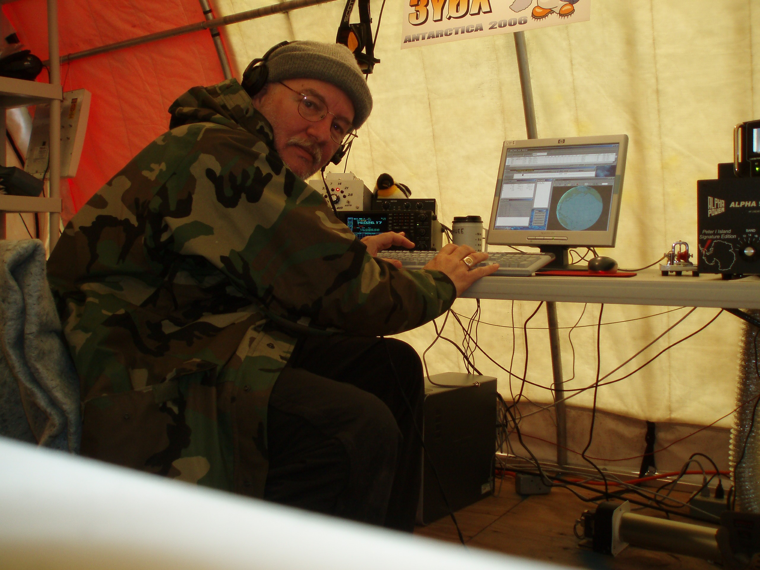

Don Dubon was first licensed in 1963 as WN6LQM in southern California. Spending 23 years in the United States Marine Corps. Don retired in 1996 and moved to the Dayton, Ohio area. Don has been to J6 many times and holds J68DD as well as VP2EM from Anguilla. Don went to Peter 1 Island 3Y0X in 2006 and visits TI5N every year for the CQWW. Don is the current President of the Southwest Ohio DX Assosiation (SWODXA)and is an active member in DARA as this year’s assistant Forums chairman. Don took a group of young hams to Costa Rica this summer for a DX Adventure. WWW.QSL.NET/N6JRL

